Even3 WebAPP Documentation

Contents

Introduction 2

The Interface 2

Page Explanations 3

Create Event 3

User Account 3

• Profile - 3

• History 3

Activities 4

Tickets: 4

Offer your service 5

Find Event/Services 5

Display on the Event sections contains; 6

Display on services 7

About 8

Appendix 8

# Introduction

The app is meant to match event creators with vendors.

That is, after you create an event and sent an invite to your friends, you will be given recommendations of rated vendors like cake makers, etc around. Other features includes sales of tickets for paid events.

# The Interface

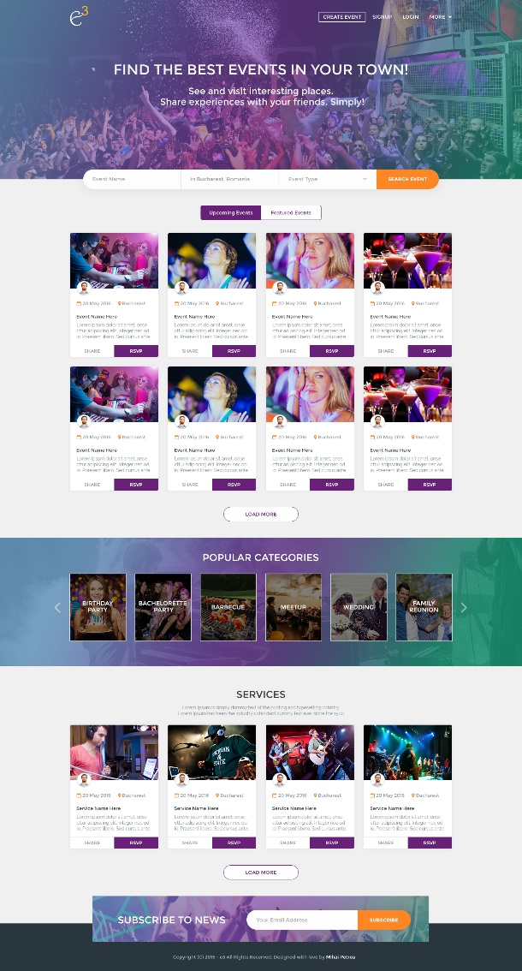This is the home/landing page which features everything about the Webapp.

The SPA is divided into sections. Which shows:

1. Search Filter
2. Events (Upcoming and featured)
3. Popular categories
4. Services
5. Subscribe section. (Newsletter)

*** Please do not forget to put navigation on most of the pages, E.g. after a search, links like back to results are not to be excluded.

* **Create Event** leads to the form (**Crete-Event**)
* **Signup** Leads to the form (**Signup**)
* **Login** bring up the Skin on the file (**Pop-Up**)
* **More** will have a dropdown menu with About Even3 and FAQ.

<\*\*\*\*\***When a user is logged in**, *****>

* **More** section will have the profile and the **Profile Menu** listed on dropdown bar with the A**bout.** & **FAQ** inclusive.
* **Login** will become **Logout <**WUL** />**
* Clicking on **any of the events** will show the event details and when users are trying to RSVP a login will be requested.
* while clicking **load more** takes users to the file **(Search)**
* “**Categories**” is a filter (When each events and services are created, users select a category for them)
* Clicking on any of the **services** should lead to the file (**Service**)
* Share links should not be restricted by user login but for anyone to **RSVP,** they have to be logged in.
* **The Search Algorithm is to let the most relevant by location, date.**
* **In the case event of creation of event where services are to be suggested, to the user, the results are to be the most relevant by location.**

# Page Explanations

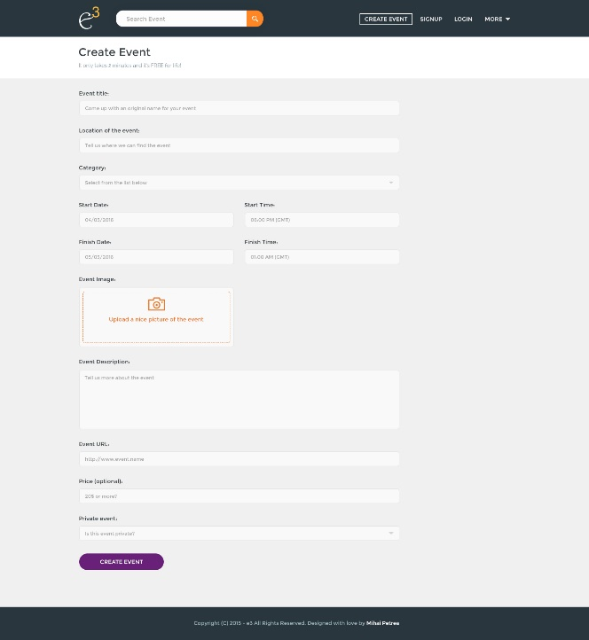Create Event (file name **Crete Event**) – is a form taking details of event, like title, location, time, RSVP information and gives the options to clarify if the events are paid or free.

Most of the sections are self-explanatory, more attentions should be placed on:

1. The (**Calendar**)

2. The **Currency** for the paid event should be from a drop down menu with a list of world currencies.

3. Making event **Public** or **Private**

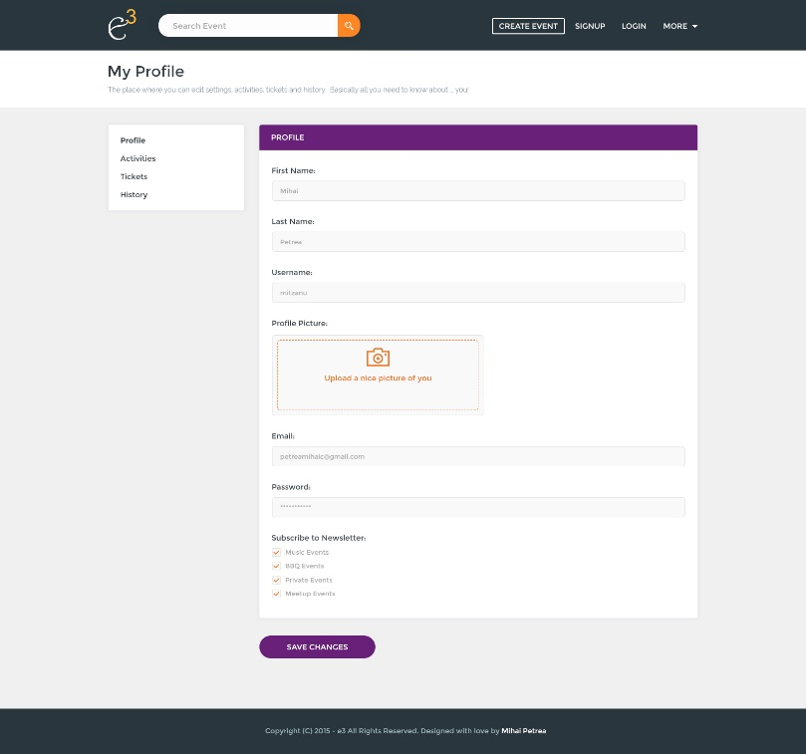User Account (File name: **My-Profile**) – contains profile, user’s activities, saved tickets and history.

* Profile - which displays editable and updateable versions of all the information requested in the Signup form and including options like notifications and interests.
* History – Contains a log of all events attended and hosted

Activities: Leads to two submenus: My Events and My Services

My Events: Lists event that the user is hosting and events they will be attending.

* 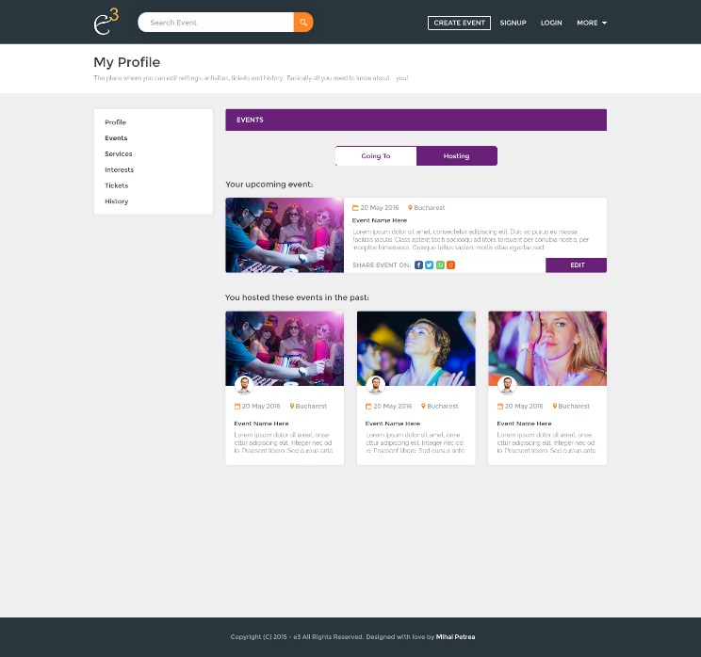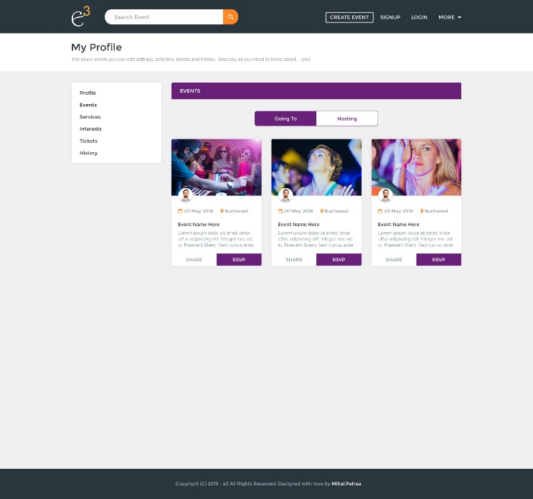**Hosted events are editable** since it’s the user that created them.

My Services: It is just the same at my events; let users edit and manage all services that the user created and saved/bookmarked. In the case of services, its only will be having **Saved** and **Offered** Services as options, where offered services are editable.

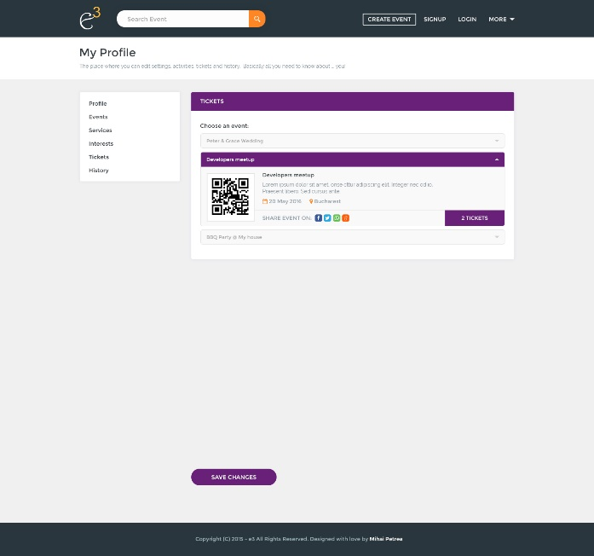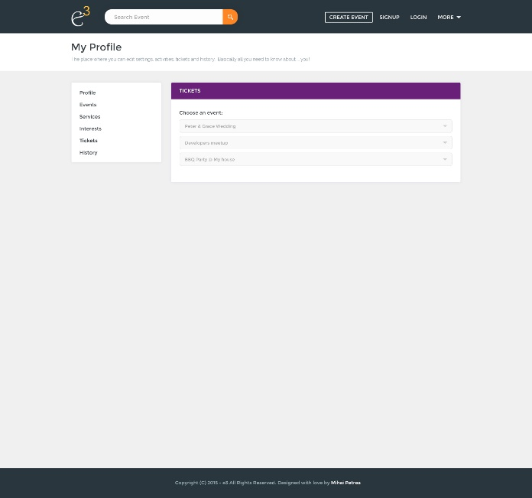Tickets: Tickets of paid events will be listed here. And when expanded it can be viewed on **Ticket-Open**

Offer your service: Is also another form which let vendors talk about what they offer. More or less like create event page without dates, but allows adding of services and prices.

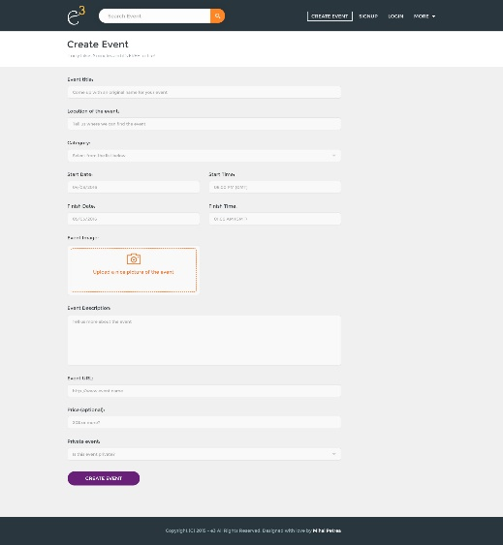

Find Event/Services – This is the page where results are displayed for all events and services; it contains filters like Search box, location and dates, though by default, it will be at the user’s geolocation and date.

|  |  |
| --- | --- |
| Events | Services |
| RESULTS | |

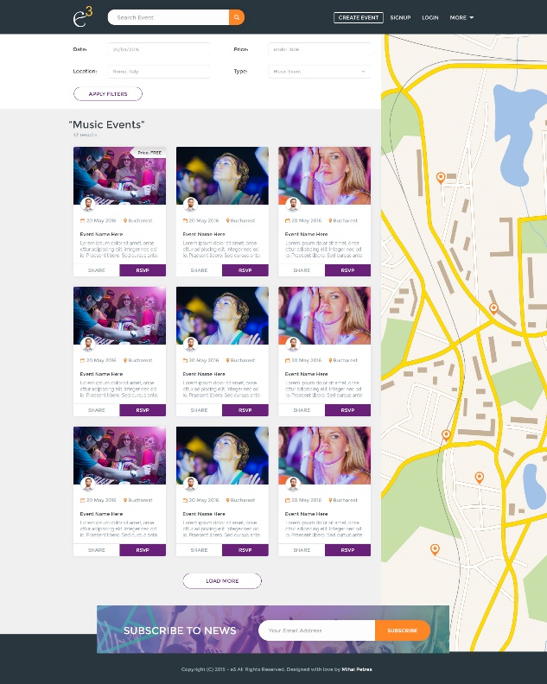 A tab allows the switching between searching for events and services but the form structures are the same.

* Users can rsvp an event without seeing the details of it at the result display should say briefly about the event, display the price and include a share link.
* Users can also save/bookmark vendors without opening the details, as the result should display some details about the vendor like title, ratings, and brief introduction of the services.

Clicking each results will show more detailed display of its contents.

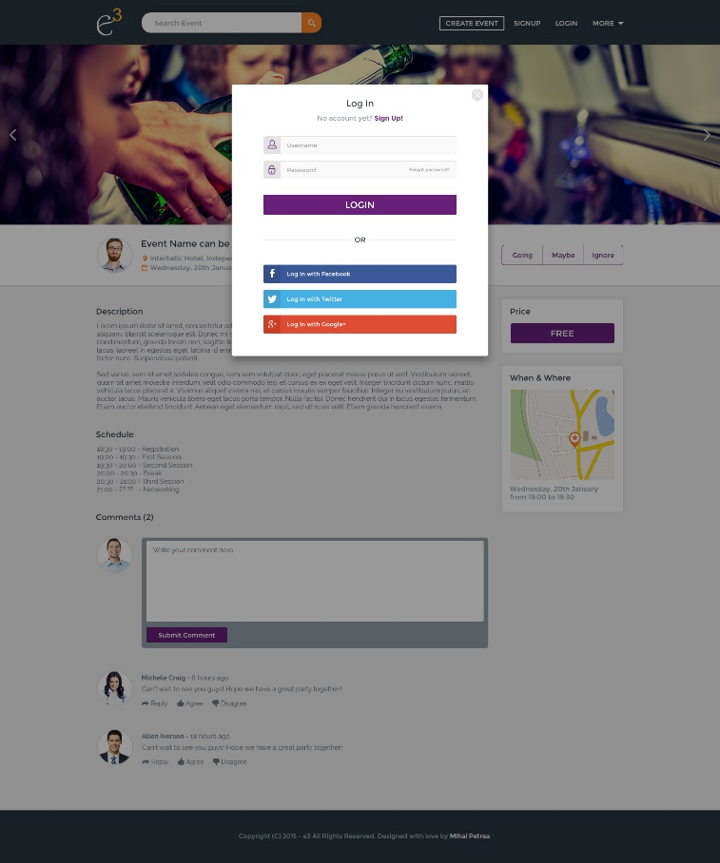

The page opens, while the login box pops up.

If users closes it, its fine, they will be able to view the information, but when actions like:

**Events:** Paying for events, RSVP-Going/Not-Going and Comment

**Services:** Hire, Rating, Comment

Users should be logged in.

And if user is a new user, the can use the signup form to sign up.

Password reset form will come in the next phase.

### Display on the Event sections contains;

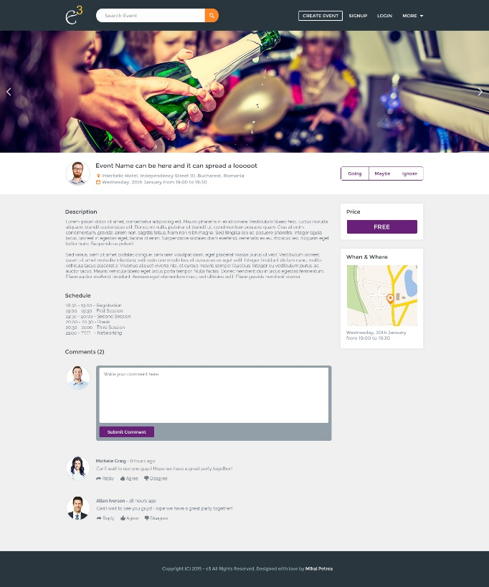Event details, the weather forecast of the event location for the event date, Contact button to the event organizer, share link to repost on social media or send by email, RSVP button to opt for (Going, Not Going, Not Sure) and in the case of a paid event, the rsvp leads to a payment page.

Attendees can comment texts, emoticon and pictures. (The reply button is concluded to be removed.)

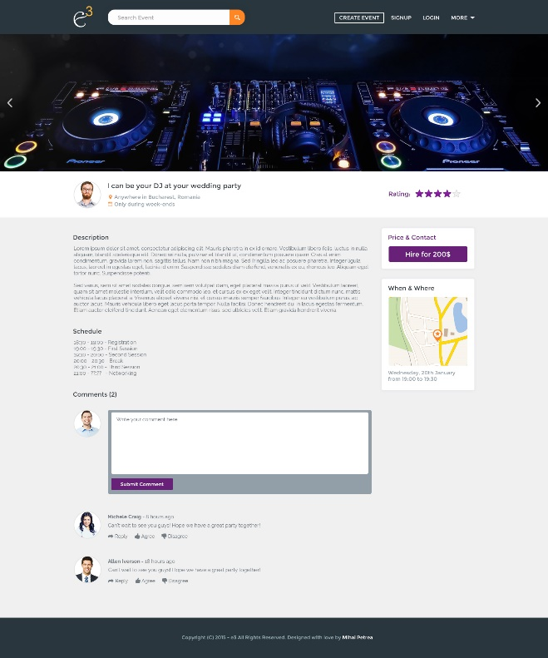Display on services contains details of the vendor, star ratings (should be open for any users to rate), contact, share link and comments.

The HIRE button sends an automated message to the vendor to contact the user and the user.

About: Will be a basic summary of what is written in the introduction updating that is ok

Notes: a very mobile friendly/compactible conversion is needed.

* When an events is shared from the app or via email as a link, it will bring users to web app, and for them to react (Accept or decline), it will prompt them to login, if the close the login skin, they will only be able to view the event just as on the login page.
* Password reset and signup confirmations pages are not to be excluded in the development.
* Pictures are fine, but majority of them can display on larger devices like tablets to pcs only while on mobile phones, pictures should be limited. All we want to achieve it speed, but if you can make it sleekly and light with pictures…. We are fine.

# Update:

* Due to the fact that there is a difference in the size of the picture scale used in the mobile application and the web application, pictures uploaded are getting stretched. there it is concluded to make the event and services page like this.

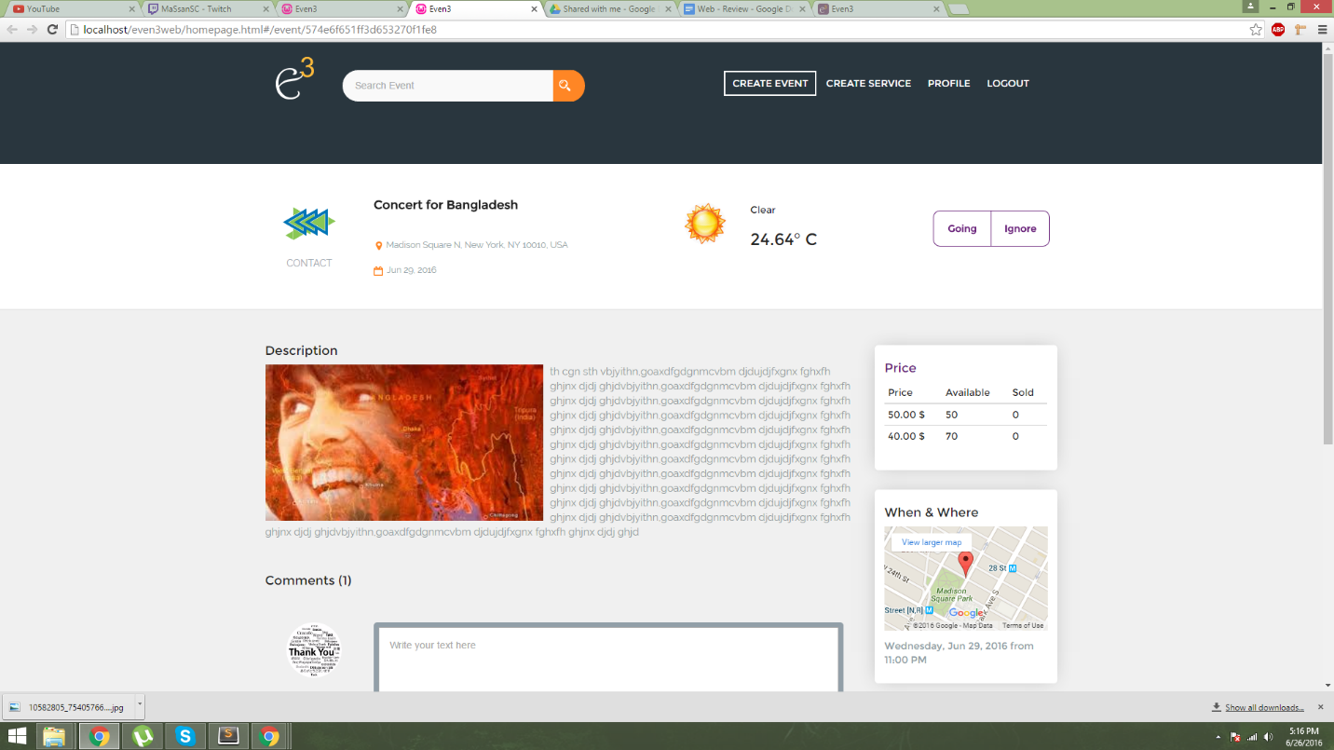

# Appendix

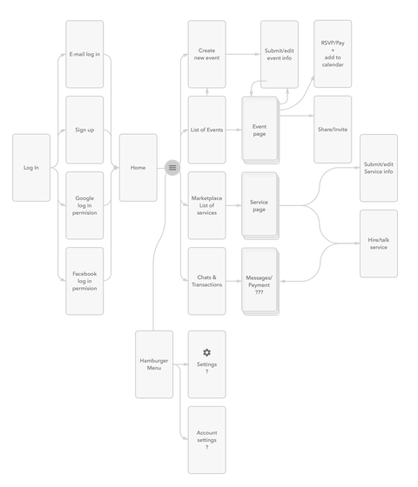Just to guide the navigation, I have attached a sitemap of the mobile prototype, some parts of it are eliminated but it’s very close to the actual design. The description above actually says it more accurately.